BENEFITS OF ALFALFA IN CROP ROTATIONS
Nicole Tautges, Emily Woodward, and Dan Putnam¹
¹ N. Tautges (netautges@ucdavis.edu), Chief Scientist, Russell Ranch Sustainable Agriculture Facility. University of California Davis. One Shields Ave., Davis, CA 95616; Emily Woodward (eewoodward7@gmail.com), U.S. Geological Survey, 3020 State University Drive
Sacramento, CA 95819; Dan Putnam (dhputnam@ucdavis.edu), Cooperative Extension Specialist, Dept. of Plant Sciences, University of California Davis. One Shields Ave., Davis, CA 95616

ABSTRACT
Alfalfa was historically an important forage and leguminous perennial rotation crop depended on to rejuvenate soil nitrogen and tilth. However, declining market value and competition from high value crops has contributed to declining alfalfa acreages in the western U.S. While meaningful increases in alfalfa price are not likely on the horizon, a proper valuation of the effects of alfalfa in rotation could incentivize adding alfalfa back into crop rotations for its benefits for soil health, which have been poorly characterized and understudied compared to the nitrogen credit. We compared a three-year alfalfa crop's effects on soil biological, chemical, and physical soil health indicators at i) the end of the alfalfa phase, ii) compared to an annual corn "control" rotation, and iii) in the following tomato crop, in the Mediterranean growing climate of northern California. Soil microbiological biomarkers were nearly 50% greater, and mycorrhizal fungal numbers were 66% greater, at the end of three-year alfalfa compared to corn. Alfalfa left little leachable nitrate in the soil at the end of the season, compared to corn (10 vs. 35 micrograms g-1 of soil, respectively), and lower nitrate leaching was observed under alfalfa compared to corn both with and without cover crops. In the following tomato crop, tomato yields were positively correlated with the previous year's microbial biomarkers following alfalfa but not corn. Detrimentally, alfalfa tended to deplete soil cations, leaving low levels of potassium and calcium fertility for the following tomato crop. However, alfalfa greatly improved soil aggregation, an important indicator of soil structure, which was also positively correlated with tomato yields. In summary, alfalfa greatly benefits biological and physical soil health parameters and tightens nitrogen cycling.
INTRODUCTION
Alfalfa is the fourth most widely grown crop in the US, covering over 17 million cropland acres in 2017 (USDA-NASS, 2018). However, alfalfa acreages have been declining nationwide, as alfalfa is being replaced in rotation by commodity grains in the Midwestern U.S., and by annual vegetables in California. For example, in 2018 in California, alfalfa acreages were the lowest in history (USDA-NASS 2019). Loss of acreage is due in part to stagnation of alfalfa yields in the U.S. in the past 20 to 30 years (USDA-NASS 2019), which has limited profitability from alfalfa. To achieve yield gains, some have suggested improved optimization of cutting schedules and soil fertility management. However, it is clear that new management innovations are needed to drive alfalfa yield progress. In other crops, these new innovations have come from a greater understanding of soil dynamics, including soil biology and nutrient cycling. Alfalfa is known to form a large number of associations with soil microbes, including fungi, compared with other crops; however, knowledge of how to manage these associations, particularly mycorrhizal associations, has remained largely unexplored in alfalfa. Although there is considerable focus on soil health as a key element for sustaining our food production in the future, alfalfa has largely been omitted from that discussion.
Research on plant-soil-microbe interactions in cropping systems has expanded greatly in the past few decades, and results from this research have helped catalyze the “soil health” movement. New rotations and management practices that enhance soil health are being promoted by food companies, state and federal agencies, and crop advisors to improve long-term agricultural yields and to mitigate yield and economic risks associated with changing climate. As a perennial crop, alfalfa has obvious benefits to soil health but this crop has not been the focus of many soil health studies. Quantifying the mechanisms and benefits of alfalfa on soil health indicators has the potential to expand alfalfa acreage nationwide, as growers and conservation groups will increasingly choose alfalfa as a soil conservation crop.

CROP ROTATION EXPERIMENT
In the U.S., alfalfa is most commonly rotated with corn in the Midwest. In the western U.S., alfalfa is sometimes rotated with annual vegetable crops to break disease cycles, especially in processing tomato rotations; however, this practice has declined recently due to low alfalfa hay market prices compared to other crops. At the UC Davis Russell Ranch Sustainable Agriculture Facility, which houses a long-term cropping systems trial, a three-year alfalfa-tomato-corn-tomato rotation was added to the long-term systems in 2013 to elucidate the effects of a perennial legume in rotation with tomato on tomato productivity and soil health, compared to conventional tomato production (Figure 1) and other alternative management practices like compost application and cover cropping. Alfalfa was cut for hay 5 to 6 times per year, and corn was harvested for grain. Alfalfa greatly benefited tomato yields when in rotation, as fruit yields were 10-36% greater following three-year alfalfa, compared to following corn in a two-year tomato-corn rotation.
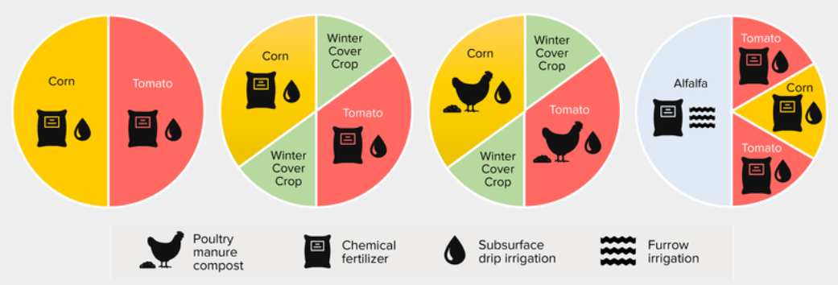
Figure 1. The two-year conventional (left) and six-year alfalfa-tomato (right) rotations of the long term systems experiment at Russell Ranch.

SOIL HEALTH AND NITRATE LEACHING FOLLOWING THE ROTATIONAL CROP
Alfalfa enhanced soil microbial biomarkers (a measurement of total microbial biomass) and the nitrogen uptake of the soil microbial pool (microbial N) after three years, compared to corn. Alfalfa fostered higher levels of mycorrhizal fungi in the soil, as mycorrhizal fungi biomarkers were 45% more abundant in alfalfa soils than corn soils (Table 1). Alfalfa likely associates with mycorrhizal fungi in their roots to a greater degree than corn.
Total dissolved nitrogen (representing a pool of potentially leachable nitrogen) in the soil solution was over 2 times greater following corn than following alfalfa (Table 1). Greater potentially leachable nitrate in the fall resulted in greater measured nitrate leaching losses over the winter (measured via ion-exchange resin bags buried at 75 cm in the soil following both alfalfa and corn). Nitrate leached with winter precipitation was lower following alfalfa compared to conventional corn, and was lower than any other conservation measure, including cover cropping and compost replacement of synthetic fertilizer (Figure 2).
Table 1. Microbial biomarkers measured with phospholipid fatty acid analysis, following three-year alfalfa and corn at Russell Ranch.
System | Total Microbial Biomass | Mycorrhizal Fungi Biomarkers | Microbial N | Total Dissolved Nitrogen
 | μg/g soil | μg/g soil | μg/g soil | μg/g soil
Alfalfa-Tomato | 43.3 | 1.6 | 5.0 | 9.4
Corn-Tomato | 31.1 | 1.1 | 1.7 | 23.5

Figure 2. (Left) Nitrate leached over the winter season following three-year alfalfa, conventional corn, cover crops following conventional corn, and cover crops following organic corn with compost, measured with ion-exchange resin bags over the 2018-19 winter season at Russell Ranch. (Right) Ion-exchange resin bag being installed under the alfalfa soil profile.
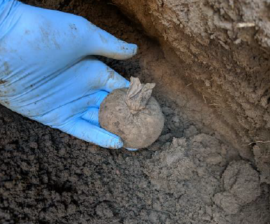
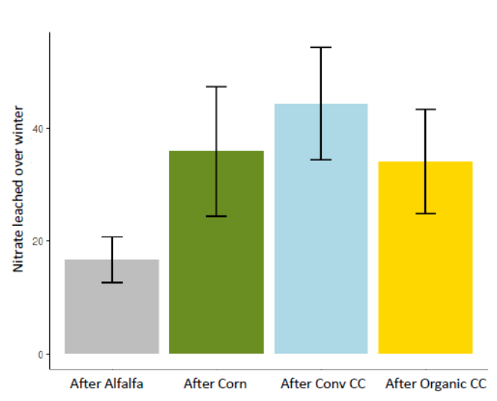
ACCOUNTING FOR THE NITROGEN CREDIT
The majority of alfalfa rotation studies have focused on quantifying the nitrogen fertilizer replacement value, or the nitrogen credit, from alfalfa before corn. To account for the residual nitrogen effect on tomato yields, we undertook a nitrogen fertilizer response experiment in tomato following alfalfa and corn in the systems in Figure 1. In the 2019 growing season, nitrogen fertilizer rates of 90, 180, and 250 lb N/acre were applied to tomato via fertigation throughout the season, and compared to a 0 lb N/acre control. Tomato yield response to synthetic nitrogen fertilizer following corn was almost two times the response following alfalfa, as tomato yields increased by 9 ton/acre for every 100 lb N/acre added following corn, compared to a 4 ton/acre increase for every 100 lb N/acre added following alfalfa (Figure 3). There was some response to nitrogen fertilizer in the alfalfa system, indicating that residual nitrogen was benefiting the tomato crop and explaining part of the yield benefit from rotating with alfalfa.
Figure 3. Tomato fruit yield response to synthetic nitrogen fertilizer following alfalfa (green line) compared to following corn (blue line) in 2019 at Russell Ranch near Davis, CA.

ARE TOMATO YIELD EFFECTS RELATED TO SOIL HEALTH INDICATORS FROM THE PREVIOUS CROPPING YEAR?
While analysis of the 2019 tomato cropping year is ongoing, there is some evidence that tomato fruit yields were related to microbial community measures from the previous year’s rotational crop. Tomato fruit yields in 2019 were 10% greater following alfalfa than corn, and were positively correlated with microbial biomass nitrogen and total microbial biomass measured at the end of the 2018 year following alfalfa and corn. Interestingly, tomato yields were not correlated with microbial measures from 2019, suggesting that a more causational relationship may have occurred, with the presence and/or functions of the microbial community in the previous year’s rotation crop resulting in carryover conditions that benefited the tomato crop (rather than a correlation being present in 2019 resulting from favorable soil conditions for both microbes and the tomato crop. Soil structure (aggregation) was strongly positively correlated with tomato yields as well, indicating that a significant benefit of alfalfa in rotations could be improvement of soil structure and tilth. Improving soil structure in vegetable rotations could also benefit soil water holding capacity and infiltration, important soil health indicators for ensuring the sustainability of alfalfa production in the semiarid West.

